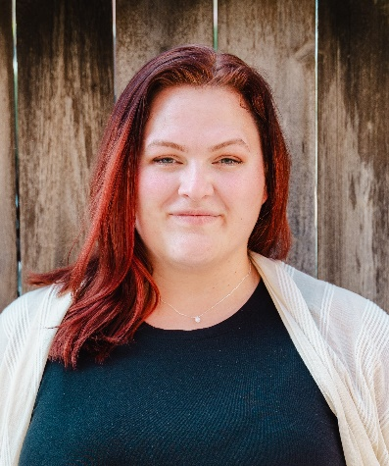

**ROLES IN PREPERATION**

Magda Sorel *The Consul*

Donna Anna *Don Giovanni*

**OPERA ROLES**

Countess Almaviva *Le nozze di Figaro* Wichita State University Opera 2024

Suor Angelica *Suor Angelica* Wichita State University Opera 2023

Suor Angelica (cover) *Suor Angelica*  Saluzzo Opera Academy 2023

Una Novizia *Suor Angelica*  Saluzzo Opera Academy 2023

Nettie+ *Carousel* University of Minnesota Duluth Opera 2023

Fiordiligi+ *Cosi Fan Tutte* University of Minnesota Duluth Opera 2023

Little Buttercup *H.M.S. Pinafore* University of Minnesota Duluth Opera 2022

Prince Orlofsky+ *The Bat Act II* University of Minnesota Duluth Opera 2021

Countess Almaviva + *Le nozze di Figaro* University of Minnesota Duluth Opera 2020

**CHORAL PERFORMING EXPERIANCE**

Chorus Cavalleria rusticana Lyric Opera of the North 2023

Soprano / Section Leader Duluth Superior Symphony Orchestra 2023

University Singers / Soprano / Section Leader University of Minnesota Duluth           2020 – 2023

Chamber Singers / Soprano                                                   University of Minnesota Duluth             2020 / 2023

Choir / Soprano and Soloist North Iowa Area Community Collage 2018 – 2020

Singers / Soprano                      North Iowa Area Community Collage 2018 – 2020

**CONCERT/RECITALS**

Soloist Senior Recital University of Minnesota Duluth 2023

Soloist University Wind Ensemble University of Minnesota Duluth 2023

Soloist Junior Recital University of Minnesota Duluth 2022

**AWARDS AND HONORS**

Graduate Staff Assistant 2023 – 2025

North Central Regional NATS Vocal Audition / Winner in Age Category 2023

Matinee Musicale Scholarship 2023

Duluth Superior Symphony Orchestra Bakke Scholarship 2022 – 2023

University of Minnesota Duluth Gershgol Music Scholarship 2022 – 2023

Minnesota NATS Vocal Audition / Semi Finalist 2022

**EDUCATION AND TRAINING**

M.M. Vocal Performance in Opera, Wichita State University Anticipated 2025

B.M. Vocal Performance, University of Minnesota Duluth 2023

**TEACHERS** **CONDUCTORS**  **DIRECTORS** **MASTERCLASSES**

Dr. Cristina Castaldi Kevin Class Alan Held Peter Leonard

Rachel Inselman Maria Sensi Sellner Marni Raab Eric McEnaney

Jayson Ryner Dr. Richard Robbins Cecilia Stinton Jack Swanson

Dirk Meyer Alice Pierce

**OTHER SKILS**

Opera Studio Social Media Manager

University of Minnesota Duluth University Singers President

University of Minnesota Duluth Music Student Association Vice President

Musical Theater Experience

+ – Scenes performance